12th International Conference on Organizational Discourse

“Silence, Significance and White Space”

***Amsterdam, Wednesday 13th July-Friday 15th July, 2016***

***Pre-conference Workshop 12th July, 2016***

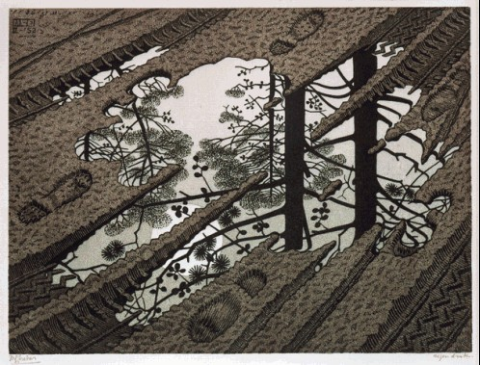

Puddle © 2015 The M.C. Escher Company-Holland. All rights reserved. [*www.mcescher.com*](http://www.mcescher.com/)

We warmly welcome you to the 12th biannual Organizational Discourse Conference 2016! In this conference we take the opportunity to critically reflect on what might be seen as the dark side of the moon or blank spots on a map: the unspoken or unknown, the unintelligible or inaccessible, the seemingly insignificant and all-too-mundane or new and exceptional realities of everyday organizational life. The extraordinary and the ‘infra-ordinary’ invite us to explore and chart new landscapes or to see familiar landscapes with new eyes.

For discourse studies, one such white space is perhaps what remains unsaid, what cannot be put into words, what is implied in unspoken expectations, tacit assumptions, and hidden meanings. Such silences may offer significant heuristic potential, as implied in the evergreen ‘what people do *not* say is no less interesting than what they *do* say’. Silence directs our attention to what is (in relation to what is not) omitted, forgotten, inexpressible, circumvented, negated, suppressed or tabooed. Claude Debussy once wrote that “music is the silence between the notes”. Without silence there would be no music. If silence is inherent to music, then, perhaps, what remains unsaid, undone or unknown is equally significant to people’s sayings and doings.

The problem with silence and white space is, however, that it presents itself to us as an absence. It is *in*significant, *in*expressible, *un*obtrusive, *un*intelligible or *un*remarkable. We often have no words for it, no recording, no fieldnotes, no map. Hence it often goes unnoticed. We do not see, hear, smell, taste, or feel it. In one Sherlock Holmes story the point is that nobody heard ‘the dog that did not bark’. And if an absence is too painful, problematic, impressive or imposing, we may prefer ineffability to the void. So, how do we capture silence in words? How to chart white spaces on a map? Can we see and describe the holes in a cheese? Perhaps we can, as philosopher Roy Sörensen pointed out, also using a food metaphor: “The hole is where there isn’t any donut; it is something immaterial, and yet you still seem to see that.” In fact, the hole is key for seeing the whole. Without it, nobody would recognize it as a doughnut. Like the dark helps to ‘enlighten’ the bright, the untold may help to sharpen our understanding of the told.

In this conference we wish to focus on veiled dimensions in contemporary organizational life. Particularly in times of increasing demands for transparency in organizations, we think addressing silence and (in)significance might offer space (white or otherwise) to discuss and explore what remains hidden. We thus push attendants to illuminate the dark sides of apparent transparencies; to give voice to what remains unsaid or unheard; to explore how silence may signify the exercise of or resistance to power; to be sensitive to semiotics outside or beyond talk and text, such as bodily gestures, looks, dress, artefacts, and the like; to narrate or talk about absent, not told or untold story; to eye the unremarkable, implicit or not-explicated; to hear the silences and subtexts in people’s talk and texts. We also hope to hear both traditional and new methods for researching absences and reading between the lines.

In keeping with past conferences, the theme for the 12th Conference deliberately constitutes a broad discursive canvas. The precise conference streams emerge from the papers themselves. At this moment, we look forward to paper presentations that organize themselves within and around the following topics (and their absence):

Culture, Collaboration and Symbolism Identity and Boundaries

Institutions, Entrepreneurship and Networks Time, Space and Materiality

Sense-making, Stories and Narrative Crisis and Transformation

Knowledge, Power and Politics Diversity and Distinction-drawing

Ethnography and Organizational Life Language, Culture and Ideology

With a nice mixture of colleagues from all over the world with a variety of disciplinary backgrounds we envisage that the Conference provides an inspirational forum in which academics with various perspectives on organization and discourse engage in lively debate and, perhaps, meaningful silence. The pre-conference workshop is for early career academics to discuss their work in some depth and detail. We expect this 12th conference to become a special edition of the discourse conference series!

Sierk Ybema, Ida Sabelis, David Sims, Michal Izak, organizing team

Nic Beech, Cynthia Hardy, Tom Keenoy, Cliff Oswick, and Robyn Thomas, advisory board

**Guidelines for Submission**

Prospective contributors interested in presenting a paper should send an abstract of approx. 1,000 words by 8th January 2016 using our online submission form (*under construction)*

Abstracts should include:

the title of the paper

the name(s), and affiliation(s) of the author(s)

an author contact address, e-mail and telephone/fax number

Notification of acceptance of papers will be given by 1st March 2016.

Full papers are required by 4th June 2016.

Conference Secretariat:

Elles Bandringa, VU University, [discourse2016.fsw@vu.nl](mailto:discourse2016.fsw@vu.nl)